Spellings – Term 5
Please learn the spellings ready for each week – tests will be on Wednesdays.

This list is consolidating the Year 1 curriculum.

Please pay attention to words which need capital letters and those which don’t – spellings will not be marked correct if capital letters are used incorrectly. In addition to this, if letters are not formed correctly this may also have an impact on your child’s score. When revising the spellings please also focus on correct letter formation with your child. We recommend re-visiting spellings that your child struggles with. Each week there will be two additional spellings from previous weeks.

Thank you – any questions please ask .
Tests will be held during the week of:  Week 1: 15/04/24  Week 2: 22/04/24  Week 3: 29/04/24  Week 4: 06/05/24  Week 5: 13/05/24  Week 6: 20/05/24 | Week 1: |  | Week 2: |  | Week 3:
 | out  mouth  sound  proud  shout | about  around  found  mound  count | down  town  frown  how  brown | own  grow  show  blow  snow | very  happy  funny  party  family | give  have  love  shove  dove
 | Week 4: |  | Week 5: |  | Week 6:
 | blue  clue  true  rescue  threw | few  drew  grew  new  Tuesday | lie  tie  pie  cried  tried | dried  died  fried  spied  tied | chief  thief  piece  brief  handkerchief | field  belief  priest  shield  grief

Spellings – Term 5
Please learn the spellings ready for each week – tests will be on Wednesdays.

This list is consolidating the Year 2 curriculum.

Please pay attention to words which need capital letters and those which don’t – spellings will not be marked correct if capital letters are used incorrectly. In addition to this, if letters are not formed correctly this may also have an impact on your child’s score. When revising the spellings please also focus on correct letter formation with your child. We recommend re-visiting spellings that your child struggles with. Each week there will be two additional spellings from previous weeks.

Thank you – any questions please ask .
Tests will be held during the week of:  Week 1: 15/04/24  Week 2: 22/04/24  Week 3: 29/04/24  Week 4: 06/05/24  Week 5: 13/05/24  Week 6: 20/05/24 | Week 1: |  | Week 2: |  | Week 3:
 | key  donkey  monkey  chimney  valley | trolley  journey  turkey  jockey  kidney | want  watch  wander  wand  quality | quad  wasps  squat  quantity  squash | word  work  worm  world  worth | warm  war  towards  warn  warned
 | Week 4: |  | Week 5: |  | Week 6:
 | television  treasure  usual  measure  pleasure | decision  vision  leisure  version  visual | enjoyment  payment  agreement  achievement  adjustment | darkness  rudeness  sadness  greatness  kindness | careful  playful  thankful  helpful  wonderful | useless  careless  homeless  hopeless  spotless

Spellings – Term 5
Please learn the spellings ready for each week – tests will be on Wednesdays.

This list is consolidating the Year 3 curriculum.

Please pay attention to words which need capital letters and those which don’t – spellings will not be marked correct if capital letters are used incorrectly. In addition to this, if letters are not formed correctly this may also have an impact on your child’s score. When revising the spellings please also focus on correct letter formation with your child. We recommend re-visiting spellings that your child struggles with. Each week there will be two additional spellings from previous weeks.

Thank you – any questions please ask .
Tests will be held during the week of:  Week 1: 15/04/24  Week 2: 22/04/24  Week 3: 29/04/24  Week 4: 06/05/24  Week 5: 13/05/24  Week 6: 20/05/24 | Week 1: |  | Week 2: |  | Week 3:
 | teacher  stretcher  dispatcher  catcher  butcher | richer  scorcher  preacher  cruncher  watcher | scheme  chorus  echo  chemist  character | stomach  monarch  school  anchor  chaos | dialogue  unique  grotesque  plaque  mosque | vague  league  plague  fatigue  antique
 | Week 4: |  | Week 5: |  | Week 6:
 | science  scene  discipline  scissors  ascends | scented  fascinate  scenery  crescent  descend | ball  bawl  break  brake  male | mail  fair  fare  berry  bury | accidentally  breathe  century  eight  consider | guard  heard  peculiar  possible  quarter

Mathematical skills to practice at home this term:
This term we will be concentrating on fractions, money and mass.
- Equivalent mass conversions (grams, kilograms, millilitres and litres)
- Adding and subtracting mass, capacity and volume
- Adding fractions with the same denominator
- Subtracting fractions with the same denominator
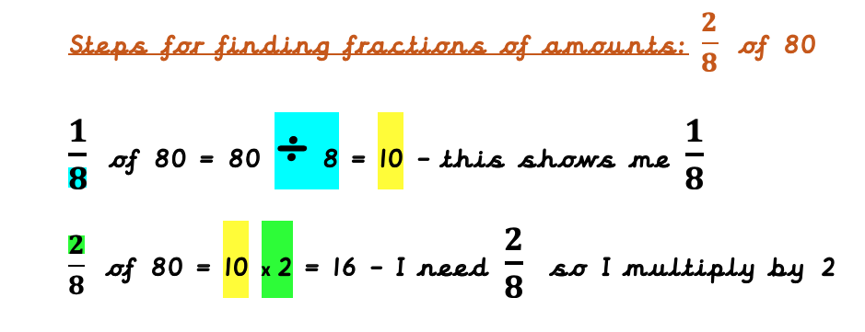
- Finding fractions of amounts
- Converting pounds and pence
- Adding and subtracting money
- Finding change

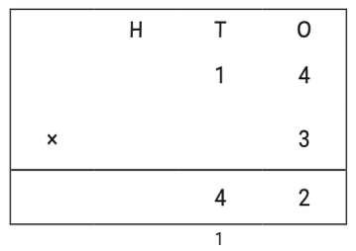
Continue to revisit:
- Column addition (within 1,000)
- Column subtraction (within 1,000)
- Mental methods within addition e.g 198 + 4 = 198 +2 +2 = 202
- Mental methods within subtraction e.g 273 – 7 = 273 – 3 – 4 = 266
- Short Multiplication
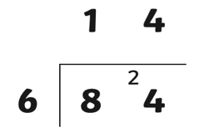
- Short Division
- Equivalent fractions
- Finding ½, 1/3, ¼ and ¾ of amounts

