Spellings – Term 4 -
Please learn the spellings ready for each week – tests will be on Wednesdays.

This list is consolidating the Year 1 curriculum.

Please pay attention to words which need capital letters and those which don’t – spellings will not be marked correct if capital letters are used incorrectly. In addition to this, if letters are not formed correctly this may also have an impact on your child’s score. When revising the spellings please also focus on correct letter formation with your child. We recommend re-visiting spellings that your child struggles with. Each week there will be two additional spellings from previous weeks.

Thank you – any questions please ask .
Tests will be held during the week of:  Week 1: 19/02/24  Week 2: 26/02/24  Week 3: 04/03/24  Week 4: 11/03/24  Week 5: 18/03/24  Week 6: 25/03/24 | Week 1: |  | Week 2: |  | Week 3:
 | herb  verb  her  term  fern | person  germ  stern  perch  mermaid | better  summer  sister  after  never | under  winter  brother  ever  river | girl  shirt  third  bird  first | turn  hurt  burst  church  Thursday
 | Week 4: |  | Week 5: |  | Week 6:
 | food  pool  moon  zoo  soon | tool  boots  spoon  afternoon  boom | book  cook  foot  wood  good | shook  brook  stood  took  wool | goes  goat  boat  dominoes  woe | toe  doe  road  soap  coat

Spellings – Term 4 -
Please learn the spellings ready for each week – tests will be on Wednesdays.

This list is consolidating the Year 2 curriculum.

Please pay attention to words which need capital letters and those which don’t – spellings will not be marked correct if capital letters are used incorrectly. In addition to this, if letters are not formed correctly this may also have an impact on your child’s score. When revising the spellings please also focus on correct letter formation with your child. We recommend re-visiting spellings that your child struggles with. Each week there will be two additional spellings from previous weeks.

Thank you – any questions please ask .
Tests will be held during the week of:  Week 1: 19/02/24  Week 2: 26/02/24  Week 3: 04/03/24  Week 4: 11/03/24  Week 5: 18/03/24  Week 6: 25/03/24 | Week 1: |  | Week 2: |  | Week 3:
 | nicer  writer  baker  looser  safer | simpler  hoped  loved  largest  closest | patting  humming  dropping  running  hopping | clapping  sitting  flipping  wrapping  slipping | patted  hummed  dropped  clapped  clipped | wrapped  napped  ripped  drummed  dragged
 | Week 4: |  | Week 5: |  | Week 6:
 | all  ball  walk  call  talk | always  fall  small  also  bald | mother  brother  nothing  cover  money | other  some  dozen  wonder  done | last  past  father  class  grass | pass  plant  path  bath  rather

Spellings – Term 4 -
Please learn the spellings ready for each week – tests will be on Wednesdays.

This list is consolidating the Year 3 curriculum.

Please pay attention to words which need capital letters and those which don’t – spellings will not be marked correct if capital letters are used incorrectly. In addition to this, if letters are not formed correctly this may also have an impact on your child’s score. When revising the spellings please also focus on correct letter formation with your child. We recommend re-visiting spellings that your child struggles with. Each week there will be two additional spellings from previous weeks.

Thank you – any questions please ask .

Tests will be held during the week of:  Week 1: 19/02/24  Week 2: 26/02/24  Week 3: 04/03/24  Week 4: 11/03/24  Week 5: 18/03/24  Week 6: 25/03/24 | Week 1: |  | Week 2: |  | Week 3:
 | arrival  burial  comical  magical  emotional | national  personal  optional  survival  tropical | battle  settle  article  humble  struggle | terrible  possible  example  capable  adjustable | gently  simply  humbly  nobly  durably | terribly  incredibly  responsibly  wrinkly  possibly
 | Week 4: |  | Week 5: |  | Week 6:
 | basically  frantically  logically  tragically magically | publicly  dramatically  historically  automatically  specifically | truly  slyly  fully  duly  shyly | wholly  drily  coyly  happily  daily | address  mention  arrive  occasionally  certainly | probably  experience  reign  history  sentence

Mathematical skills to practice at home this term:
This term we will be concentrating on length and fractions. As well as formal methods, we will be working on our mental methods and quick recall.
- Equivalent lengths and conversions (metres, centimetres and millimetres)
- Adding and subtracting lengths
- Finding the perimeter
- Being confident in fraction language from Year 2 (denominator, numerator, find half, quarter, third and three quarters)
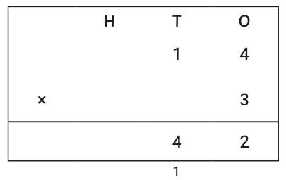
- Comparing and ordering fractions
- Equivalent fractions
Continue to revisit:
- 1 more / 1 less within 1,000
- 10 more / 10 less within 1,000
- 100 more / 100 less within 1,000
- Column addition (within 1,000)
- Column subtraction (within 1,000)
- Mental methods within addition e.g 198 + 4 = 198 +2 +2 = 202
- Mental methods within subtraction e.g 273 – 7 = 273 – 3 – 4 = 266
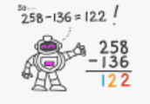
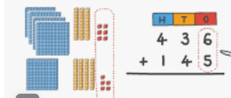
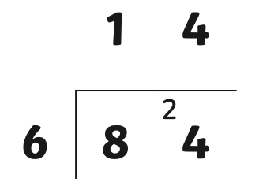
- Short Multiplication
- Short Division
- Doubles
- Halves

