Spellings – Term 3 -
Please learn the spellings ready for each week – tests will be on Wednesdays.

This list is consolidating the Year 1 curriculum.

Please pay attention to words which need capital letters and those which don’t – spellings will not be marked correct if capital letters are used incorrectly. In addition to this, if letters are not formed correctly this may also have an impact on your child’s score. When revising the spellings please also focus on correct letter formation with your child. We recommend re-visiting spellings that your child struggles with. Each week there will be two additional spellings from previous weeks.

Thank you – any questions please ask .
Tests will be held during the week of:  Week 1: 04/01/24  Week 2: 08/01/24  Week 3: 15/01/24  Week 4: 22/01/24  Week 5: 29/01/24  Week 6: 05/02/24 | Week 1: |  | Week 2: |  | Week 3:
 | home  those  woke  hope  hole | mole  spoke  joke  bone  phone | June  use  tune  flute  plume | rude  tube  flume  huge  rule | car  jar  park  arm  garden | hard  dark  stars  art  shark
 | Week 4: |  | Week 5: |  | Week 6:
 | feel  tree  green  meet  week | see  free  sheet  feet  seek | each  peach  reach  teach  lead | leaf  leap  beak  squeak  real | head  bread  meant  instead  wealth | sweat  threat  spread  dead  deaf

Spellings – Term 3 -
Please learn the spellings ready for each week – tests will be on Wednesdays.

This list is consolidating the Year 2 curriculum.

Please pay attention to words which need capital letters and those which don’t – spellings will not be marked correct if capital letters are used incorrectly. In addition to this, if letters are not formed correctly this may also have an impact on your child’s score. When revising the spellings please also focus on correct letter formation with your child. We recommend re-visiting spellings that your child struggles with. Each week there will be two additional spellings from previous weeks.

Thank you – any questions please ask .
Tests will be held during the week of:  Week 1: 04/01/24  Week 2: 08/01/24  Week 3: 15/01/24  Week 4: 22/01/24  Week 5: 29/01/24  Week 6: 05/02/24 | Week 1: |  | Week 2: |  | Week 3:
 | cry  fly  dry  try  reply | shy  spy  sky  why  July | tries  replies  cries  spies  supplies | flies  copies  babies  carries  lorries | copied  replied  spied  fried  applied | relied  identified  multiplied  magnified  supplied
 | Week 4: |  | Week 5: |  | Week 6:
 | happier  happiest  angrier  angriest  drier | driest  tidier  tidiest  funnier  funniest | hiking  shining  joking  hoping  smiling | surprising  loving  writing  coming  caring | every  everybody  great  break  steak | even  pretty  beautiful  after  fast

Spellings – Term 3 -
Please learn the spellings ready for each week – tests will be on Wednesdays.

This list is consolidating the Year 3 curriculum.

Please pay attention to words which need capital letters and those which don’t – spellings will not be marked correct if capital letters are used incorrectly. In addition to this, if letters are not formed correctly this may also have an impact on your child’s score. When revising the spellings please also focus on correct letter formation with your child. We recommend re-visiting spellings that your child struggles with. Each week there will be two additional spellings from previous weeks.

Thank you – any questions please ask .

Tests will be held during the week of:  Week 1: 04/01/24  Week 2: 08/01/24  Week 3: 15/01/24  Week 4: 22/01/24  Week 5: 29/01/24  Week 6: 05/02/24 | Week 1: |  | Week 2: |  | Week 3:
 | straight  strainer  fainted  claimed  waist | snail  painter  chained  failure  waiter | freight  vein  weigh  reins  eight | eighteen  reign  veil  neighbour  sleigh | obey  osprey  prey  disobey  they | convey  they  survey  conveyor  grey
 | Week 4: |  | Week 5: |  | Week 6:
 | calmly  exactly  deadly  bravely  boldly | gladly  deeply  clearly  hourly  quickly | great  main  grown  missed  meet | grate  mane  groan  mist  meat | build  describe  imagine  library  natural | ordinary  promise  recent  suppose  weight

Mathematical skills to practice at home this term:
This term we will be concentrating on multiplication and division. As well as formal methods, we will be working on our mental methods and quick recall.
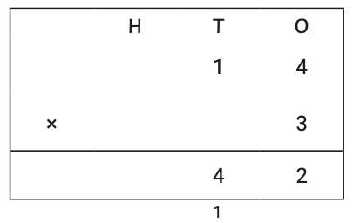
- 3s, 4s and 8s (multiplication and division facts)
- Short multiplication
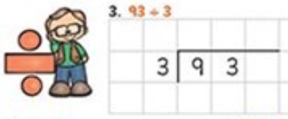
- Short division
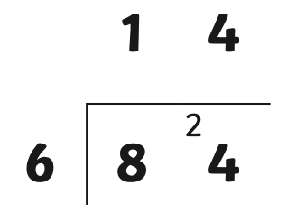

To revise:
- Multiplication and division facts 2s, 5s and 10s – next term we will be moving onto division so this is very important!
- Doubles
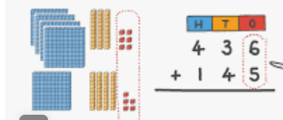
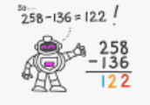
- Halves
- Number bonds to and within 10 (mental)

Continue to revisit:
- 1 more / 1 less within 1,000
- 10 more / 10 less within 1,000
- 100 more / 100 less within 1,000
- Column addition (within 1,000)
- Column subtraction (within 1,000)
- Mental methods within addition e.g 198 + 4 = 198 +2 +2 = 202
- Mental methods within subtraction e.g 273 – 7 = 273 – 3 – 4 = 266
- Number bonds to 1000 (quick recall) 600 + 300 = 1,000
- Number bonds to 1,000 (tens) 540 + 460 = 1,000

